Package #_________________
[Provided by DISA]
COCOM/Service/Agency/Field Activity Letterhead

From: DOD organization sponsor Date: DOD Sponsor Letter signed

Memorandum For: DISA/NS
Appointed Validation Official (2nd Ind)
DOD CIO

SUBJECT: Non-DOD DISN Connection (Validation) for [Name of Non-DOD Entity or Contractor] located at [City, State]

1. OPERATIONAL REQUIREMENT: (Must answer all sections/questionnaires)
- Operational need for connection:
- State the DOD mission, program, or project to be supported by this connection
- Describe the operational relationship between the DOD sponsor and the contractor or other non-DOD entity as it pertains to the mission, program or project
- Describe how the contractor or other non-DOD entity tasks are performed without the connection
- Describe specifically how the connection will support the DOD sponsor organization and contractor or other non-DOD entity mission tasks
- Indicate any DOD benefit(s) derived by implementing the request as stated (include any mission-criticality and/or time-sensitivity issues)
- Classification/Type of work to be conducted by the contractor or other non-DOD entity:
- Specify Classified or Unclassified and/or level, e.g. (Unclassified//for official use only (U//FOUO) – Secret and Top Secret.
- Specify type whether command and control, research and development, modeling and simulation, etc. (Specific to Statement of Work (SOW)/Contract)
- Frequency of use: Describe how frequently the contractor or other non-DOD entity will be required to use this connection in support of your DOD mission, program or project

2. MISSION PARTNERS/INFORMATION:
- DOD Sponsor Unit:
- DOD Sponsor: (name/title/unclass e-mail/classified e-mail/phone number)
- DOD Security Individual: (name/title/unclass e-mail/classified e-mail/phone number from the sponsoring organization that will be assuming responsibility for this circuit)
- Computer Network Defense Service Provider (CNDSP):
- DOD Sponsor IA Representative for Combatant Command/Service/Agency/Field Activity (CC/S/A):
- Non-DOD Entity/Contractor/Corporate (no acronyms) including the complete connection location address (street, city, state):
- Cage Code (if revalidating an existing connection, include the CCSD #):
- Funding Source: Responsible funding Source (may or may not be a DOD Sponsor):
- If Contractor Info: Contract Number, expiration date, contracting officer name, and phone number
- Non-DOD Security FSO:

3. CONNECTION DETAILS:
- Connection location addresses (Point of Presence):
- Applications/Databases (What application and Database Connection is required):
- What Protocols are being utilized: (if applicable):
- Specific IP/URL destination addresses: (if applicable):
- Final Topology diagram and revalidation of connection/enclave:
- The topology should annotate all devices and connections in the enclave to include routers, IA equipment (firewalls/IDS/etc.), servers/data storage devices/workstations/etc., all connections, to include enclave entry and exit connections, and security classification of environment

As the DOD Sponsor, I must ensure connectivity requirements are properly coordinated, periodic inspections are conducted, and adequate controls are in place in accordance with:

- DODI 8510.01, Risk Management Framework (RMF) for DOD Information Technology (IT), 12 March 2014 (ref d)
- DOD 5220.22-M, National Industrial Security Program Operating Manual (NISPOM), 28 February 2006 (ref s) for connections between DOD and contractor information systems
- DODI 8551.01, Ports, Protocols, and Services Management (PPSM), 28 May 2014 (ref e)
- DODI O-8530.2, Support to Computer Network Defense (CND), 9 March 2001 (ref k)
- CJCSI 6211.02D, Defense Information Systems Network (DISN) Responsibilities, 24 January 2012 (ref b)
- DISN Connection Process Guide; http://iase.disa.mil/connect/index.html
- DOD CIO Office Sponsor Memorandum, 14 August 2012 (ref l)

Signature _______________________
Print Name _______________________
Agency _______________________
Title/Rank _______________________
(Signed by an O-6 or equivalent)

Sample of an IT Topology Diagram
ILAP Domain Configuration @ ABCDEF Systems

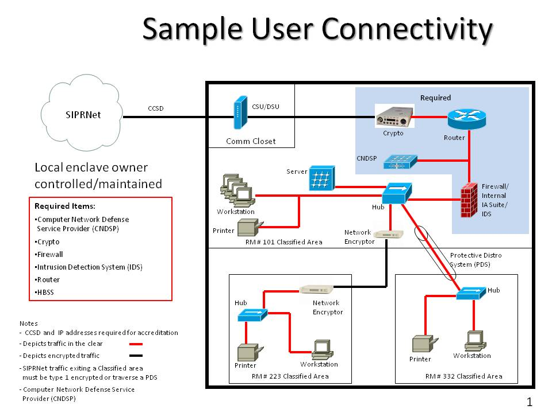
Figure 1: Sample User Connectivity
Identify equipment (e.g., LARSCOM Access T-1 XXX DSU/CSU; CISCO WC-1DSU-T1-V2-RF; Cisco 3600 Router; Cisco IDS 4210 Sensor, Cisco 4900 Catalyst Switch) and include all IP addresses, etc. Tunneling SIPRNET traffic through NIPRNET/Corporate network requires DSAWG review approval in accordance with CJCSI 6211.02D, Defense Information Systems Network (DISN) Responsibilities, 24 January 2012. (ref b)

The letter must include signature pages below. All sections in red must be filled out by the Sponsor. Signatures will be obtained within the respective offices.

1st Ind Date

We have reviewed/discussed this connection request with the partner/sponsor. Concur or non-concur.
DISN Validation Official
DISA Network Services

2nd Ind (Appointed Validation Official) Date

We have reviewed the DOD Sponsor’s request for [Non-DOD Entity/Contractor] to have a DISN connection. Recommend DOD CIO approve this connection.

SIGNATURE
CC/S/A Validation Official

